Ideation Phase
Define the Problem Statements

Date | 31 January 2025
Roll Number
Project Name
Maximum Marks | 2 Marks

Customer Problem Statement Template :
The Automated Network Request Management in ServiceNow project focuses on simplifying and accelerating the handling of network-related service requests. By leveraging ServiceNow’s service catalog, workflows, and automation capabilities, the solution eliminates manual bottlenecks and ensures requests are processed efficiently. End users can easily submit requests through a self-service portal, while automated routing, approvals, and task assignments streamline fulfillment. Where possible, integration with network automation tools enables end-to-end execution without human intervention. This results in faster turnaround, improved SLA compliance, and enhanced transparency for both users and IT teams.

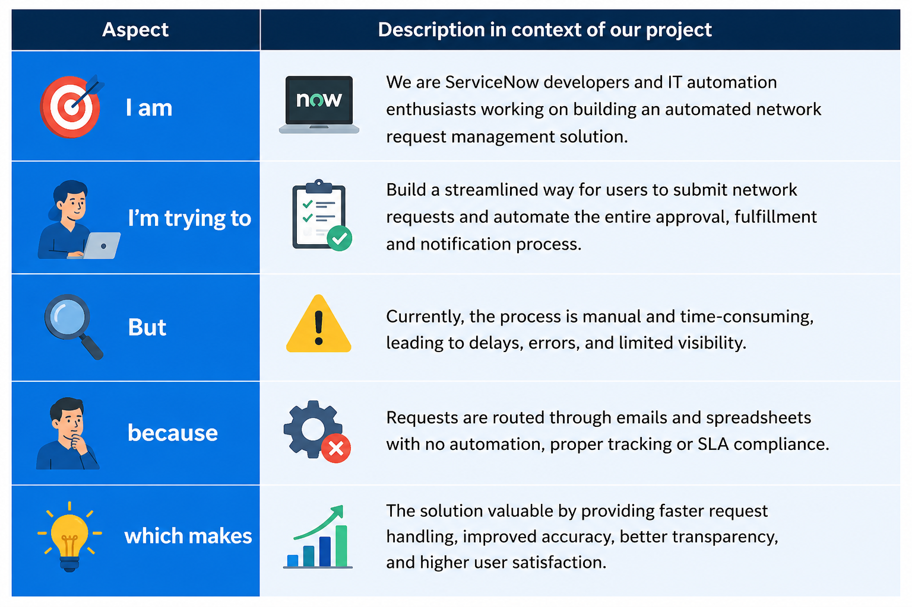
Problem Statement (PS) | I am (Customer) | I’m trying to | But | Because | Which makes me feel
PS-1
PS-2

